Date | 03 October 2026
Team ID | SWTID-2026-7735
Project Name | Auto Ticket Classification using Flow Designer
Maximum Marks | 4 Marks

Ideation Phase
Empathize & Discover
Empathy Map Canvas:
An empathy map captures knowledge about a user's behaviours and attitudes to design user-centered solutions.
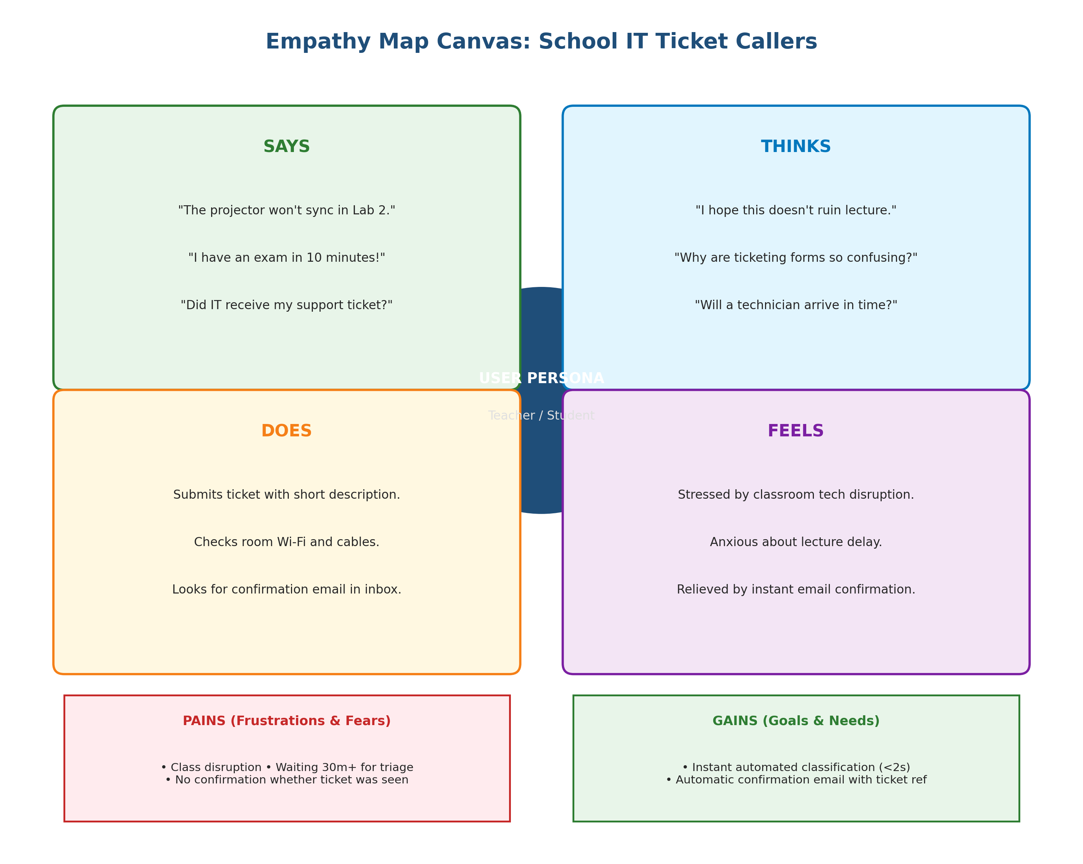
Figure 1.4: Empathy Map Canvas for School Callers and IT Resolvers
User Persona 1: School Teacher / Student (The Caller)
Canvas Dimension | Observations & Insights
1. Who are we empathizing with? | Teachers, academic faculty, and students who depend on classroom IT equipment (Wi-Fi, projectors, PCs).
2. What do they need to do? | Log issues in under 30 seconds with simple phrases like 'Wi-Fi down in Lab 2' and receive instant confirmation.
3. What do they SEE? | A blank projector screen during a lecture, 'No Internet' error on student laptops, intimidating IT drop-downs.
4. What do they SAY & DO? | They say: 'I just need someone to fix the projector right now!'. They submit tickets and wonder if anyone received it.
5. What do they HEAR? | Colleagues complaining: 'IT tickets take forever to get acknowledged', 'You have to call them directly'.
6. Pains & Gains (THINK & FEEL) | PAINS: Fear of class disruption, tedious forms.  GAINS: Immediate confirmation email, automated categorization, rapid technician dispatch.
User Persona 2: IT Helpdesk Support Staff (The Resolver)
Canvas Dimension | Observations & Insights
1. Who are we empathizing with? | Junior IT helpdesk technicians handling daily campus hardware, network, and account maintenance.
2. What do they need to do? | Focus their time and skills on physical equipment repair, access restorations, and system troubleshooting.
3. What do they SEE? | A cluttered general inbox filled with unclassified incident records waiting for manual sorting.
4. What do they SAY & DO? | They say: 'I spent half my morning just reading tickets and clicking Network or Hardware'.
5. What do they HEAR? | Escalations regarding delayed ticket response times and inconsistent categorization reports.
6. Pains & Gains (THINK & FEEL) | PAINS: Repetitive administrative triage, human categorization error.  GAINS: Zero manual triage, instant structured routing, accurate reporting.

